The four P’s of storytelling

# People:

Old Man (Player)

Tom (Grandson)

Tom’s sister

Old Man’s wife (Deceased)

# Place:

Old Man’s house

# Picture:

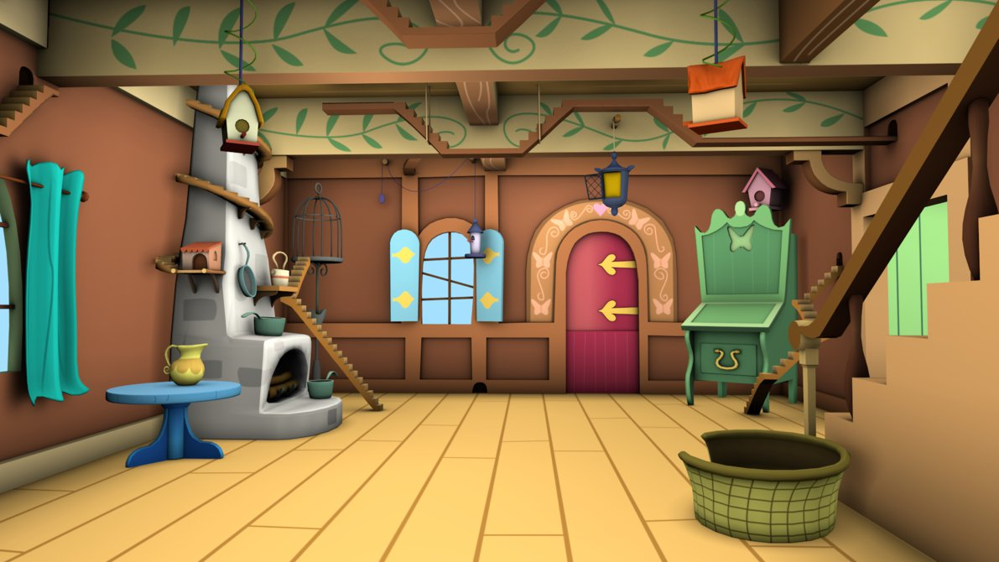

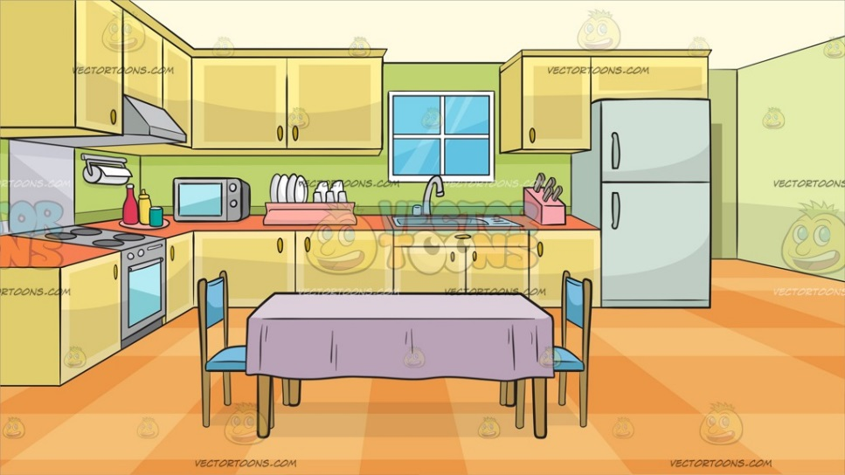

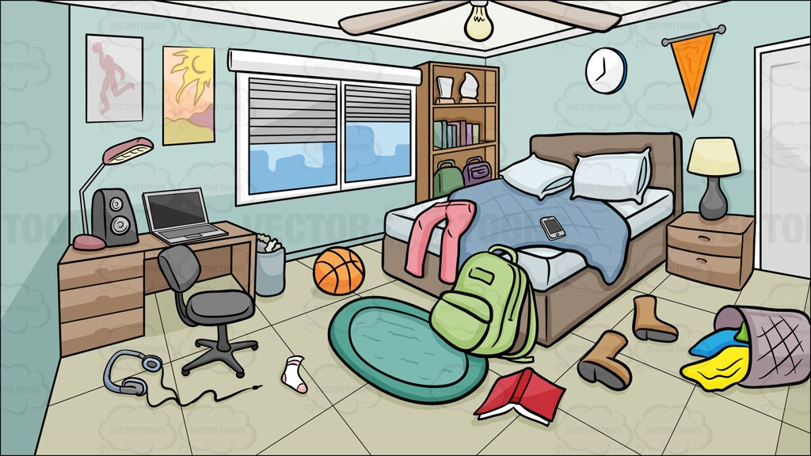



# Plot:

You play as an old man with severe dementia. After the loss of his wife he goes insane and is hospitalised. He then lives the next day in a dream while his family decide weather to pull the plug and let him die or force him to life in an insanity fuelled daydream.

Idea

* 1st person.
* Slowly losing memory.
* Play through 1 day.
* You slowly lose your memory.
* You wake up in a hospital bed surrounded by your family.

Setting:

* Old person’s house
* House contains Kitchen, Living room, Bathroom, Bedroom, Garden and Dining room.

Character Profile

Old Man

76-year-old man living alone after his wife’s death.

Severe dementia

The old man is an old man living alone after his wife has died and is living with severe dementia. He is living in an everyday week of his life with small references to show that he is loving inside of a memory. He can hear a heart rate monitor whenever there’s a dark screen during the transition of days.